Figures:

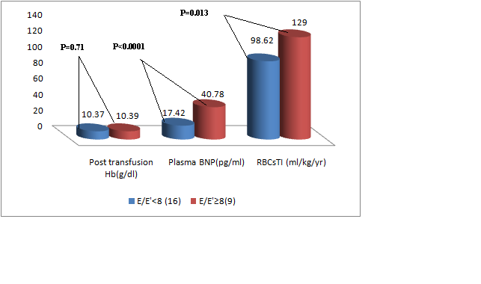
Figure 1 a Figure 1 b

Figure 2

Figure 3

