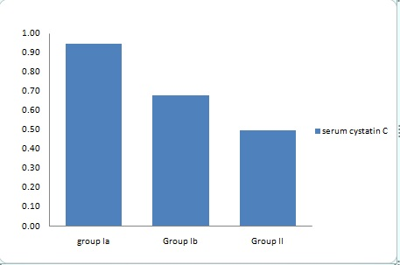
Figure 1: Comparison between studied groups regarding serum cystatin.

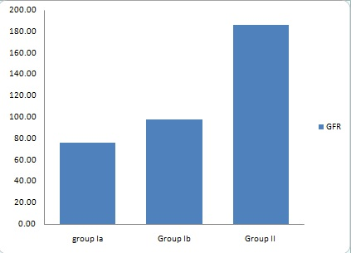

Figure 2: Comparison between studied groups regarding GFR.

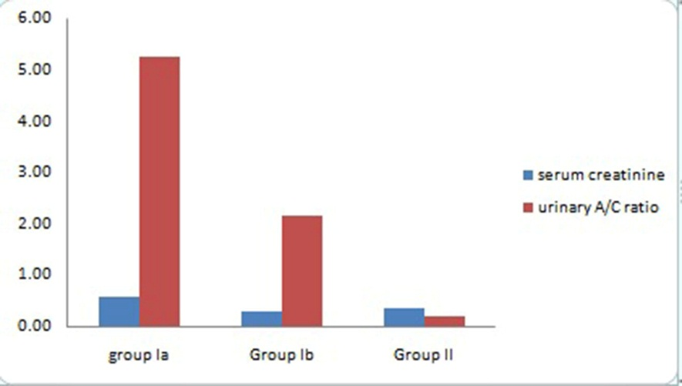

Figure 3: Comparison between studied groups regarding serum creatinine and A/C ratio.

