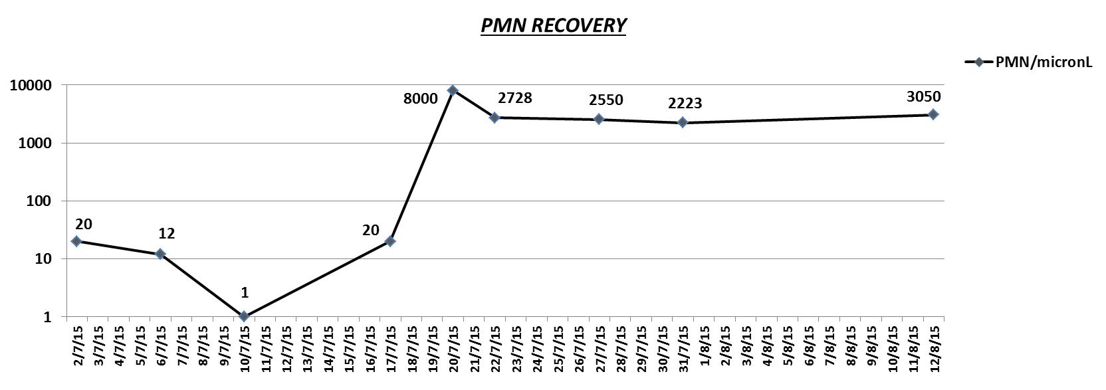

**8 G-CSF from 10/7 to 19/7**

**FIGURE 2.**

**SURGERY 31/7**