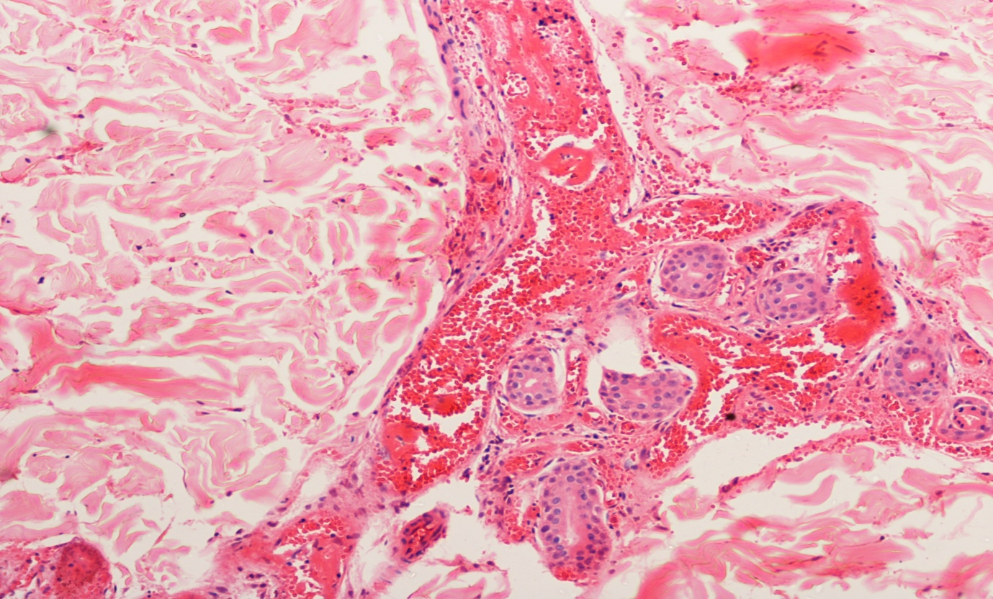
Fig 2b- Skin biopsy showing extravasation RBC in the dermis

