Figure 1

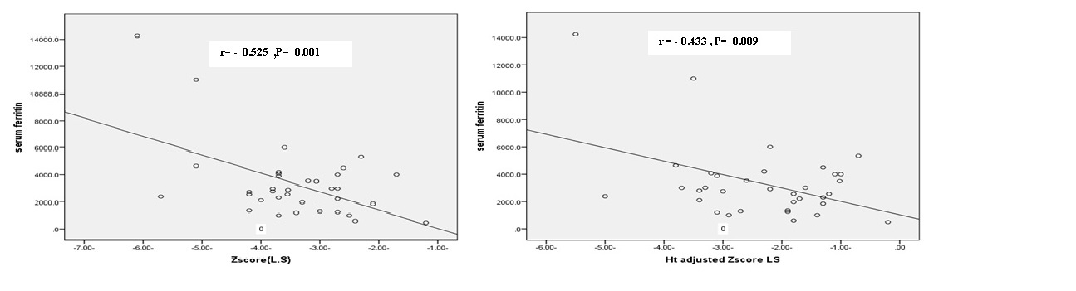

Figure.2a Figure.2b

Figure 3a Figure 3b

